Eclipse TestNG Plugin Installation

**Step1:** Check whether TestNG plugin is already available in your eclipse. Go to Window→Preferences and check for TestNG as below. **Ignore rest of the installation if you find TestNG under Preferences.**

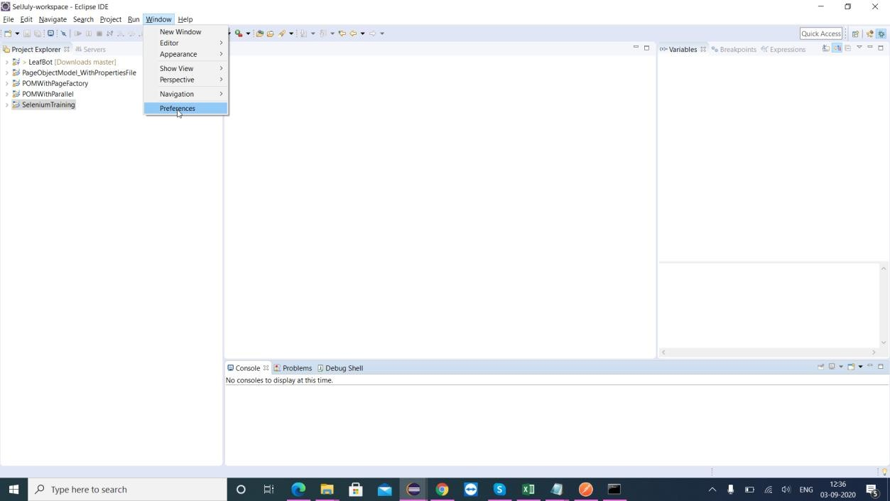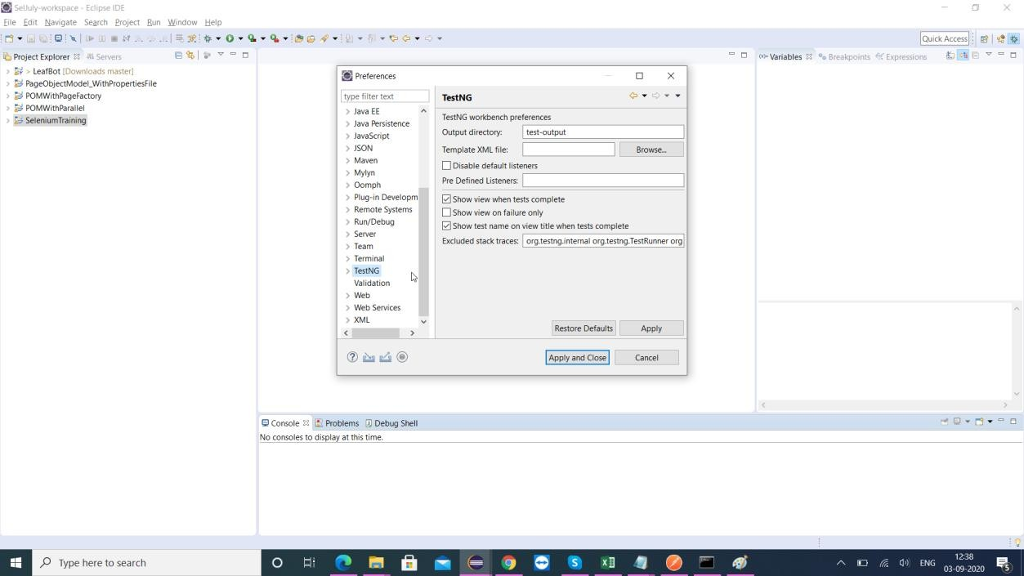

**Step2:** If you don’t find TestNG under Preferences, Go to Help→Install New Softwares…

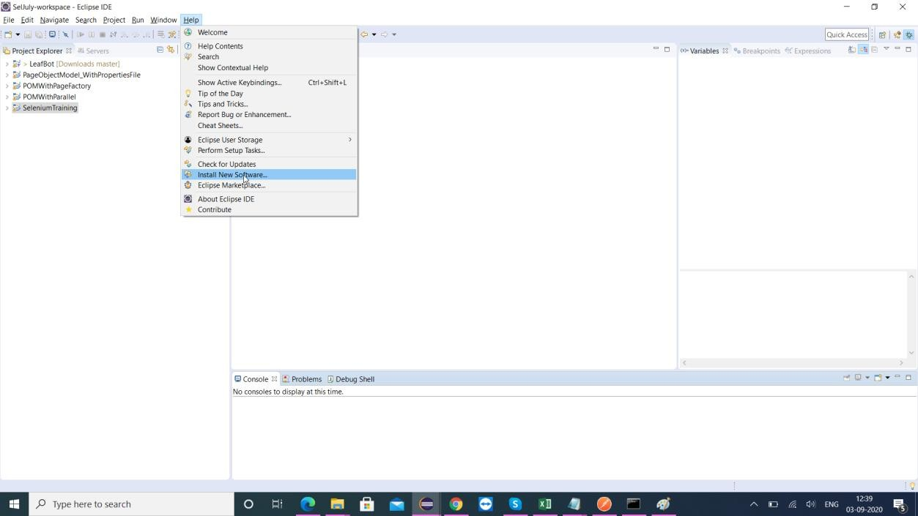

**Step3:** Click Add to enter TestNG url (https://testng.org/testng-eclipse-update-site ) as Below

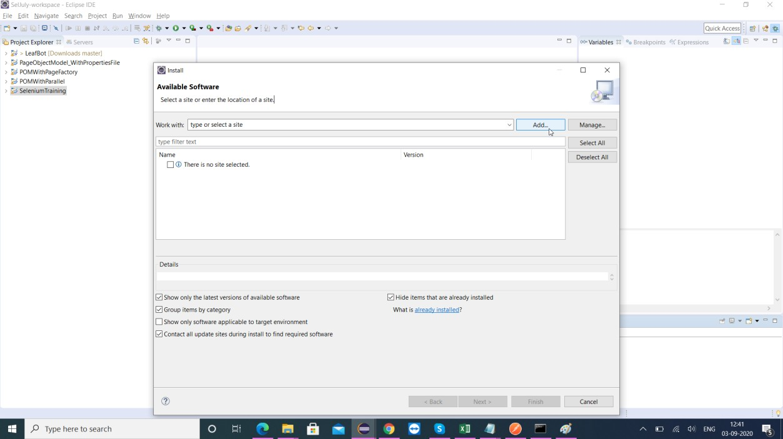

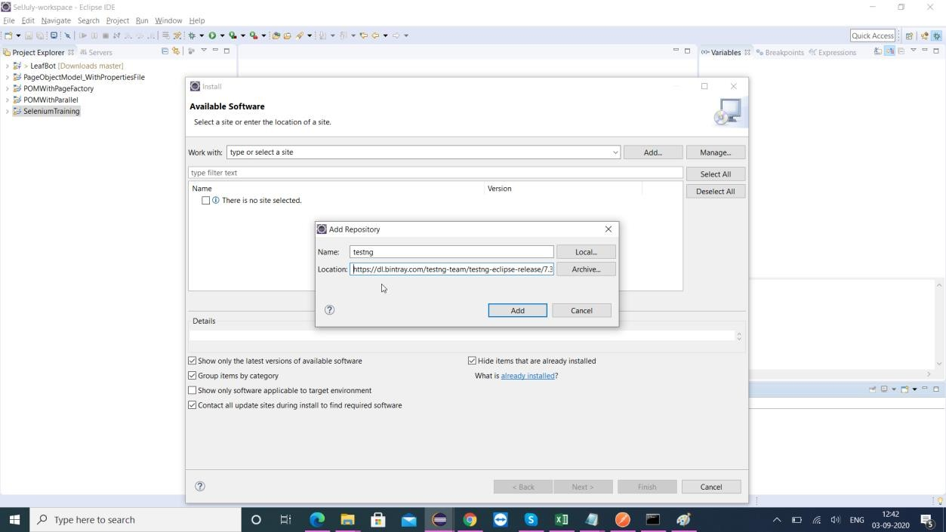

**Step4:** Select TestNG and Click next

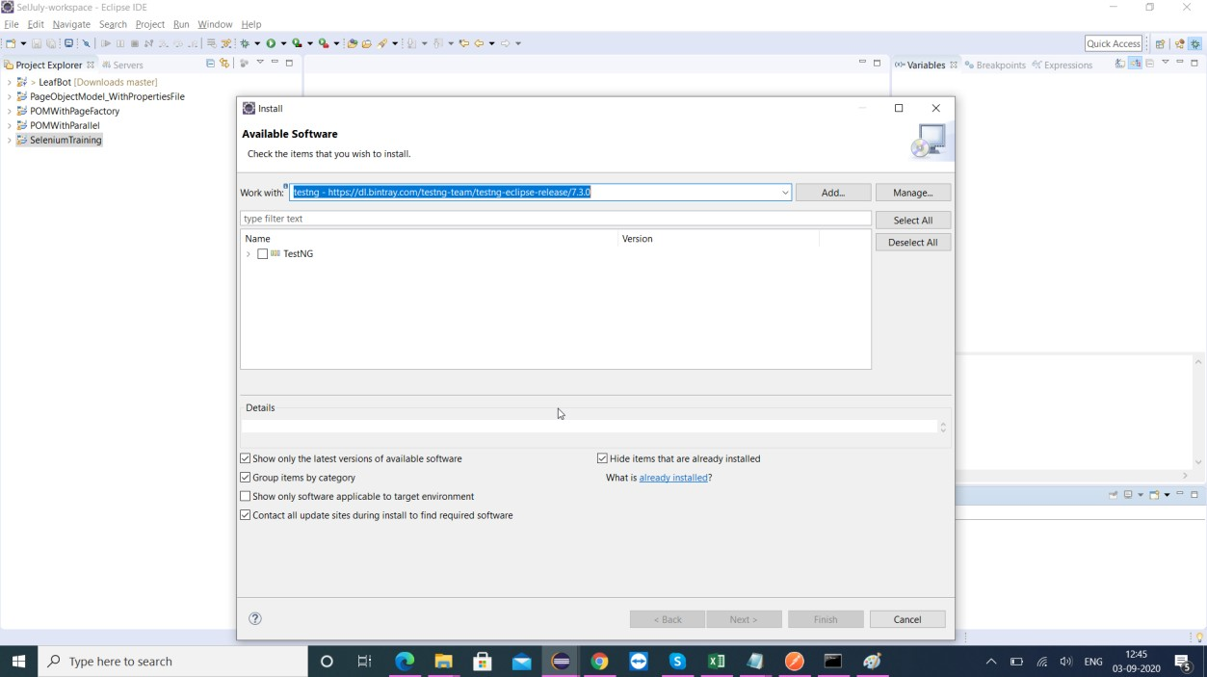

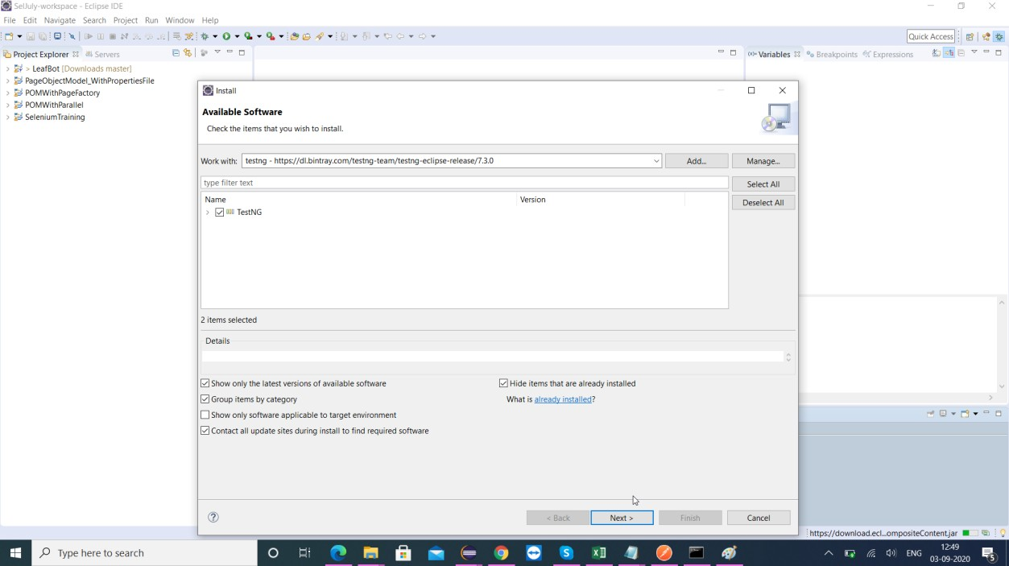

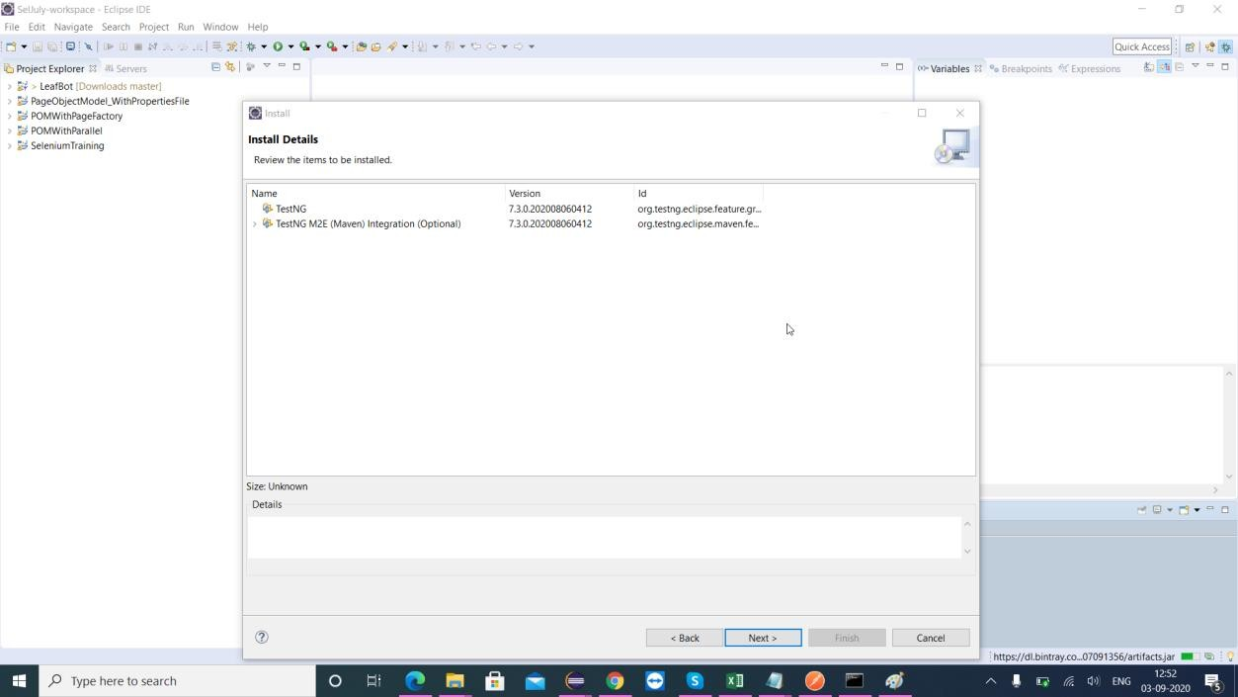

**Step5:** Accept the terms and conditions and click Finish

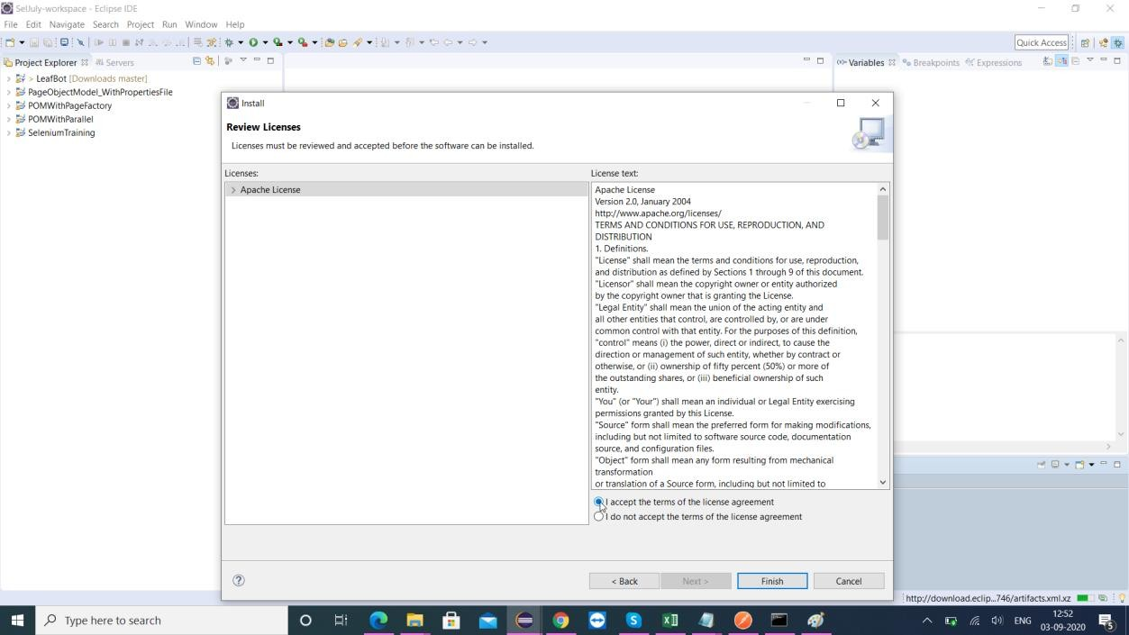

**Step6:** Click Install Anyway and Restart eclipse

